Co-4 Assessment-1
Name:M.Harini
Reg No:192521245
1.IPSec Authentication Header (AH)
Code:
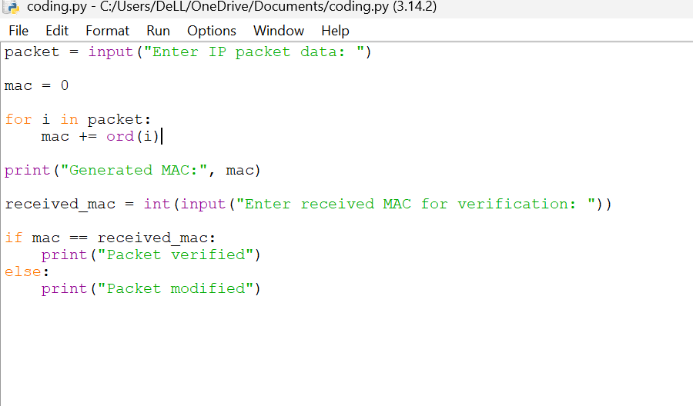

Output:
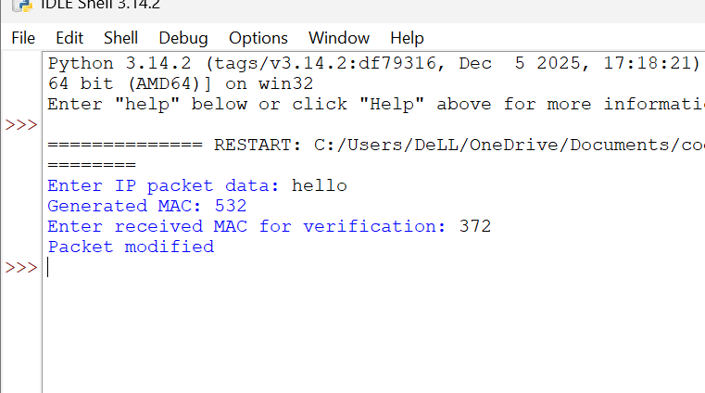
2. Encapsulating Security Payload (ESP)
Code:
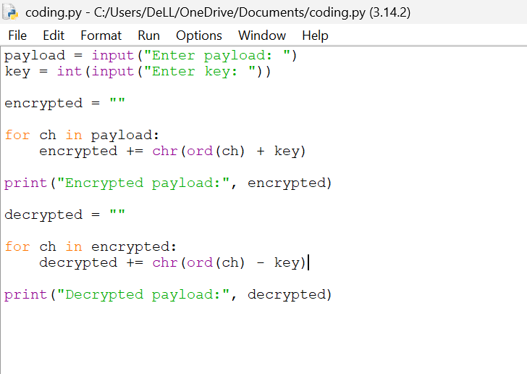
Output:
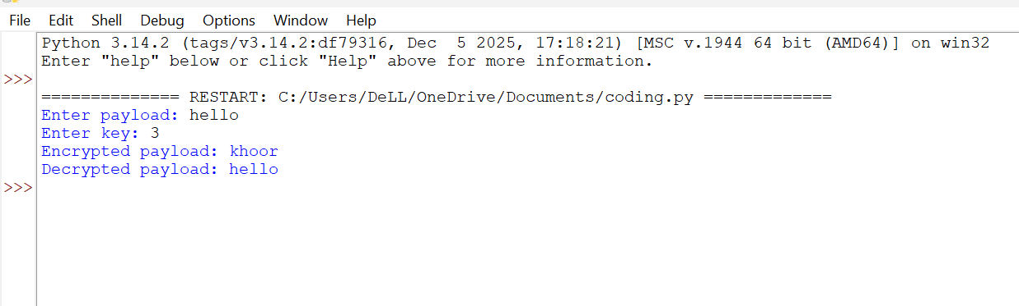

3. Security Association (SA) Management
Code:
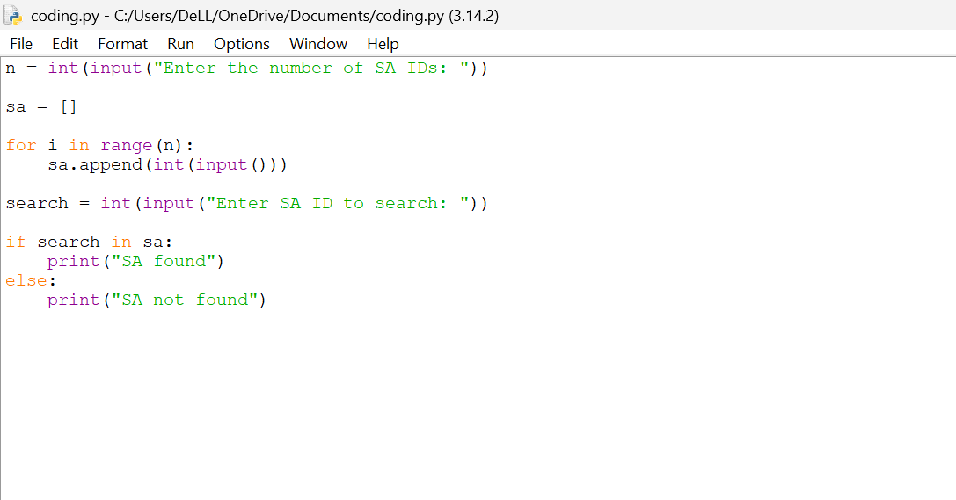
Output:
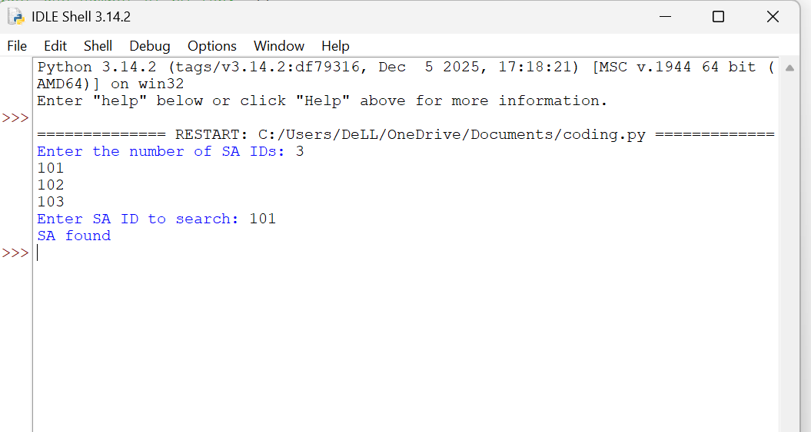

4. Pretty Good Privacy (PGP)
Code:
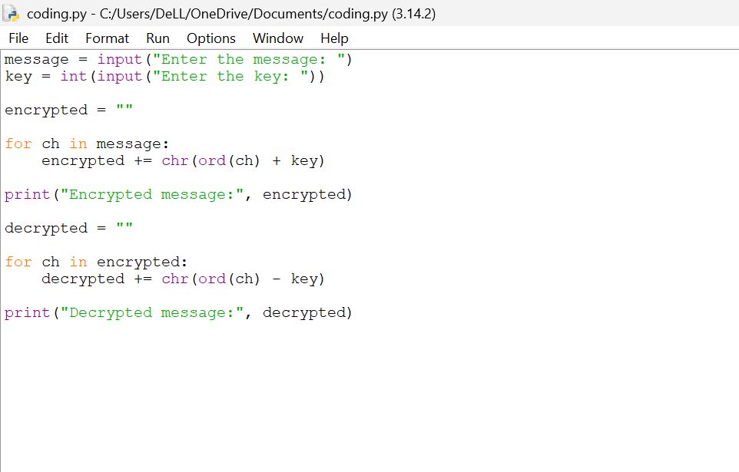
Output:
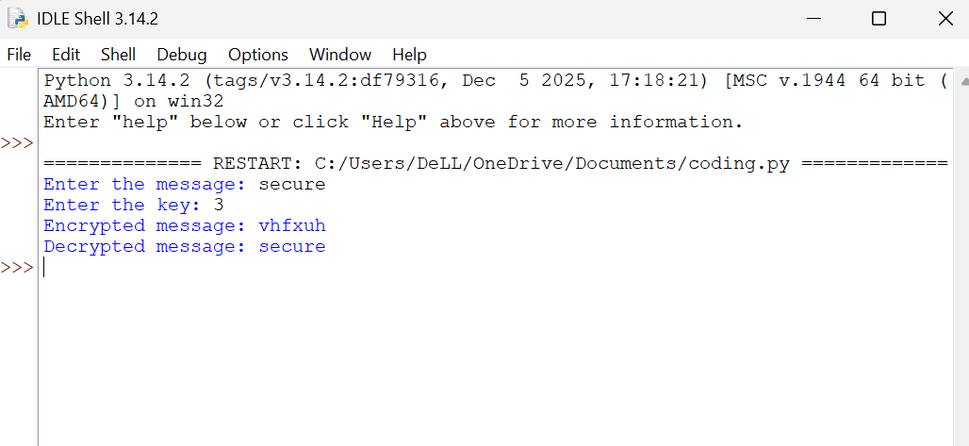

5. Email Spam Classification
Code: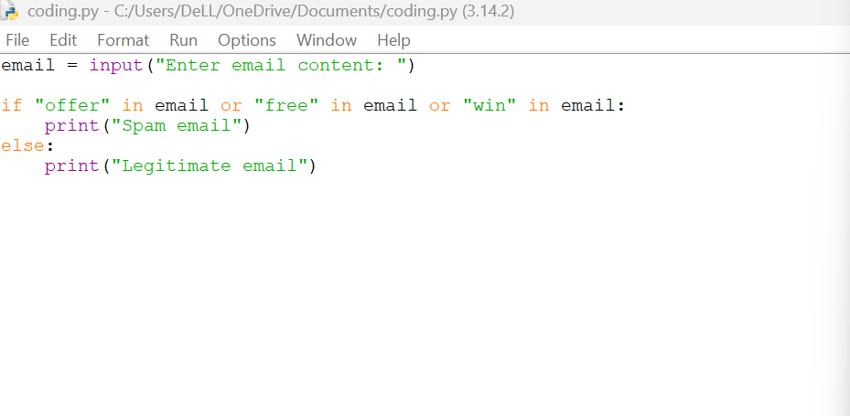
Output:
